TP5 — Cultures, Intrants et Rendements Agricoles
  - Nigeria GHS Panel Wave 4 (2018-2019) | Post-Harvest
NGUEAJIO David et Serigne Ndame LO
19 avril 2026
Table of Contents

Introduction
Ce rapport analyse les cultures pratiquées, les intrants agricoles utilisés et les rendements obtenus par les exploitations agricoles nigérianes à partir du Nigeria General Household Survey (GHS) Panel — Wave 4 (2018-2019), collecté dans le cadre du programme LSMS-ISA de la Banque Mondiale.
Note sur les fichiers de données. L’énoncé mentionne les fichiers secta3, secta5a et secta9a qui correspondent aux conventions de nommage des vagues 1 à 3. En vague 4, la structure du questionnaire agricole a été entièrement renumérotée (sections 11A à 11L). Les fichiers réellement disponibles et utilisés ici sont : - secta3ii_harvestw4.dta — roster des cultures par parcelle
- secta11c2_harvestw4.dta — intrants (engrais) par parcelle
- secta9a_harvestw4.dta — production récoltée par culture
- secta1_harvestw4.dta — roster des parcelles (superficie)

Chargement des packages et des données
## === df_crops ===
## Rows: 8,839
## Columns: 62
## $ zone <dbl+lbl> 4, 4, 4, 4, 4, 4, 4, 4, 4, 4, 4, 4, 4, 4, 4, 4, 4, 4,…
## $ state <dbl+lbl> 1, 1, 1, 1, 1, 1, 1, 1, 1, 1, 1, 1, 1, 1, 1, 1, 1, 1,…
## $ lga <dbl+lbl> 105, 111, 111, 107, 107, 107, 107, 107, 107, 107, 107…
## $ sector <dbl+lbl> 2, 1, 1, 2, 2, 2, 2, 2, 2, 2, 2, 2, 2, 2, 2, 2, 2, 1,…
## $ ea <dbl> 0, 1146, 1146, 1044, 1044, 1044, 1044, 1044, 1044, 1044, …
## $ hhid <dbl> 10009, 10031, 10031, 10061, 10061, 10061, 10061, 10061, 1…
## $ cropcode <dbl+lbl> 1080, 1080, 2190, 1020, 1080, 1121, 1124, 2060, 2080,…
## $ sa3iiq1a <dbl> 10.0, 1.0, 4.0, 15.0, 10.0, 9.0, 5.0, 10.0, 7.0, 7.0, 150…
## $ sa3iiq1c <dbl+lbl> 130, 130, 160, 130, 130, 150, 130, 130, 130, 130, 100…
## $ sa3iiq1d <dbl+lbl> 10, 10, 0, 11, 10, 1, 11, 10, 10, 10, 1, 11, 10, 1…
## $ sa3iiq1b <dbl+lbl> 1, 1, NA, NA, 1, NA, NA, NA, NA, NA, NA, NA, 1, N…
## $ sa3iiq1_conv <dbl> 9.000, 9.000, 0.480, 50.000, 9.000, 34.980, 50.000, 25.00…
## $ sa3iiq3 <dbl+lbl> 1, 2, 2, 1, 1, 1, 1, 1, 1, 1, 1, 1, 1, 1, 1, 1, 1, 1,…
## $ sa3iiq4 <dbl+lbl> 7, NA, NA, 12, 10, 12, 12, 10, 10, 11, 11, 10, 6, …
## $ sa3iiq4b <dbl> 2018, NA, NA, 2018, 2018, 2018, 2018, 2018, 2018, 2018, 2…
## $ sa3iiq5a <dbl> 5.00, NA, NA, 9.00, 8.00, 7.00, 4.00, 8.00, 6.00, 5.00, 1…
## $ sa3iiq6 <dbl> 7500, NA, NA, 18000, 25000, 55000, 24000, 28000, 24000, 2…
## $ sa3iiq7 <dbl+lbl> 1, NA, NA, 3, 3, 3, 3, 3, 3, 3, 3, 3, 3, …
## $ sa3iiq7_os <chr> "", "", "", "", "", "", "", "", "", "", "", "", "", "", "…
## $ sa3iiq8_1 <dbl> 6, NA, NA, 2, 2, 1, 2, 1, 1, 2, 2, 1, 1, 1, 7, 7, 1, 2, 2…
## $ sa3iiq8_2 <dbl> NA, NA, NA, NA, 3, 2, 3, 2, 2, 3, 3, NA, NA, NA, NA, NA, …
## $ sa3iiq8_3 <dbl> NA, NA, NA, NA, NA, NA, NA, NA, NA, NA, NA, NA, NA, NA, N…
## $ sa3iiq8_4 <dbl> NA, NA, NA, NA, NA, NA, NA, NA, NA, NA, NA, NA, NA, NA, N…
## $ sa3iiq8_5 <dbl> NA, NA, NA, NA, NA, NA, NA, NA, NA, NA, NA, NA, NA, NA, N…
## $ sa3iiq9_1 <dbl> 1, NA, NA, 1, 1, 1, 1, 1, 1, 2, 1, 1, 1, 1, 6, 7, 1, 2, 2…
## $ sa3iiq9_2 <dbl> NA, NA, NA, 2, 2, 2, 2, 2, 2, 3, 2, NA, NA, NA, 7, NA, NA…
## $ sa3iiq10 <dbl+lbl> 1, NA, NA, 1, 1, 1, 1, 1, 1, 1, 1, 1, 1, …
## $ sa3iiq10a_1 <dbl> 0, 0, 0, 0, 0, 1, 0, 1, 0, 1, 0, 1, 1, 0, 1, 0, 1, 0, 0, …
## $ sa3iiq10a_2 <dbl> 0, 0, 0, 0, 0, 0, 0, 0, 0, 0, 0, 0, 0, 0, 0, 0, 0, 0, 0, …
## $ sa3iiq10a_3 <dbl> 1, 1, 1, 1, 1, 1, 1, 1, 1, 1, 1, 1, 1, 1, 1, 1, 1, 1, 1, …
## $ sa3iiq10a_4 <dbl> 0, 0, 0, 0, 0, 0, 0, 0, 0, 0, 0, 0, 0, 0, 0, 0, 0, 0, 0, …
## $ sa3iiq10a_5 <dbl> 0, 0, 0, 0, 0, 0, 0, 0, 0, 0, 0, 0, 0, 0, 0, 0, 0, 0, 0, …
## $ sa3iiq10a_6 <dbl> 0, 0, 0, 0, 0, 0, 0, 0, 0, 0, 0, 0, 0, 0, 0, 0, 0, 0, 0, …
## $ sa3iiq10a_7 <dbl> 0, 1, 1, 0, 0, 0, 0, 0, 1, 1, 1, 0, 0, 0, 0, 0, 1, 1, 0, …
## $ sa3iiq10a_8 <dbl> 0, 0, 0, 0, 0, 0, 0, 0, 0, 0, 0, 0, 0, 0, 0, 0, 0, 0, 0, …
## $ sa3iiq10a_9 <dbl> 0, 0, 0, 1, 0, 0, 0, 0, 0, 0, 0, 0, 0, 0, 0, 0, 0, 0, 0, …
## $ sa3iiq11aa <dbl> NA, NA, NA, NA, NA, 1.00, NA, 1.00, NA, 0.25, NA, 0.50, 1…
## $ sa3iiq12a <dbl> NA, NA, NA, NA, NA, NA, NA, NA, NA, NA, NA, NA, NA, NA, N…
## $ sa3iiq13a <dbl> 5.00, 0.50, 2.00, 4.00, 2.00, 1.00, 1.00, 1.00, 0.75, 0.5…
## $ sa3iiq14a <dbl> NA, NA, NA, NA, NA, NA, NA, NA, NA, NA, NA, NA, NA, NA, N…
## $ sa3iiq15a <dbl> NA, NA, NA, NA, NA, NA, NA, NA, NA, NA, NA, NA, NA, NA, N…
## $ sa3iiq16a <dbl> NA, NA, NA, NA, NA, NA, NA, NA, NA, NA, NA, NA, NA, NA, N…
## $ sa3iiq17a <dbl> NA, 0.50, 2.00, NA, NA, NA, NA, NA, 0.25, 0.25, 10.00, NA…
## $ sa3iiq18a <dbl> NA, NA, NA, NA, NA, NA, NA, NA, NA, NA, NA, NA, NA, NA, N…
## $ sa3iiq18aa <dbl> NA, NA, NA, 2, NA, NA, NA, NA, NA, NA, NA, NA, NA, NA, NA…
## $ sa3iiq25 <dbl+lbl> NA, NA, NA, 3, NA, NA, NA, NA, NA, NA, NA, NA, NA, N…
## $ sa3iiq25_os <chr> "", "", "", "", "", "", "", "", "", "", "", "", "", "", "…
## $ sa3iiq20a <dbl> NA, NA, NA, 2, NA, NA, NA, NA, NA, NA, NA, NA, NA, NA, NA…
## $ sa3iiq20b <dbl+lbl> NA, NA, NA, 130, NA, NA, NA, NA, NA, NA, NA…
## $ sa3iiq20b_os <chr> "", "", "", "", "", "", "", "", "", "", "", "", "", "", "…
## $ sa3iiq20c <dbl+lbl> NA, NA, NA, 11, NA, NA, NA, NA, NA, NA, NA, NA, NA, N…
## $ sa3iiq21 <dbl> NA, NA, NA, 8000, NA, NA, NA, NA, NA, NA, NA, NA, NA, NA,…
## $ sa3iiq22_1 <dbl> NA, NA, NA, 1, NA, NA, NA, NA, NA, NA, NA, NA, NA, NA, NA…
## $ sa3iiq22_2 <dbl> NA, NA, NA, 2, NA, NA, NA, NA, NA, NA, NA, NA, NA, NA, NA…
## $ sa3iiq22_3 <dbl> NA, NA, NA, NA, NA, NA, NA, NA, NA, NA, NA, NA, NA, NA, N…
## $ sa3iiq23_1 <dbl> NA, NA, NA, 1, NA, NA, NA, NA, NA, NA, NA, NA, NA, NA, NA…
## $ sa3iiq23_2 <dbl> NA, NA, NA, 2, NA, NA, NA, NA, NA, NA, NA, NA, NA, NA, NA…
## $ sa3iiq23_3 <dbl> NA, NA, NA, NA, NA, NA, NA, NA, NA, NA, NA, NA, NA, NA, N…
## $ sa3iiq23_4 <dbl> NA, NA, NA, NA, NA, NA, NA, NA, NA, NA, NA, NA, NA, NA, N…
## $ sa3iiq23_5 <dbl> NA, NA, NA, NA, NA, NA, NA, NA, NA, NA, NA, NA, NA, NA, N…
## $ sa3iiq26 <dbl+lbl> NA, NA, NA, 2, NA, NA, NA, NA, NA, NA, NA, NA, NA, N…
## $ sa3iiq27 <dbl+lbl> NA, NA, NA, NA, NA, NA, NA, NA, NA, NA, NA, NA, NA, N…
## === df_fert ===
## Rows: 8,293
## Columns: 41
## $ zone <dbl+lbl> 4, 4, 4, 4, 4, 4, 4, 4, 4, 4, 4, 4, 4, 4, 4, 4, 4, …
## $ state <dbl+lbl> 1, 1, 1, 1, 1, 1, 1, 1, 1, 1, 1, 1, 1, 1, 1, 1, 1, …
## $ lga <dbl+lbl> 105, 105, 111, 107, 107, 107, 107, 107, 107, 107, 1…
## $ sector <dbl+lbl> 2, 2, 1, 2, 2, 2, 2, 2, 2, 2, 2, 2, 2, 2, 2, 2, 2, …
## $ ea <dbl> 0, 0, 1146, 1044, 1044, 1044, 1044, 1044, 1044, 1044, 1…
## $ hhid <dbl> 10009, 10009, 10031, 10061, 10061, 10061, 10061, 10061,…
## $ plotid <dbl> 1, 2, 1, 1, 2, 3, 4, 5, 6, 1, 2, 3, 1, 2, 3, 1, 2, 3, 1…
## $ s11c2q10 <dbl+lbl> 1, 1, 2, 2, 2, 2, 2, 2, 2, 2, 2, 2, 2, 2, 2, 2, 2, …
## $ s11c2q11a <dbl> 8, 5, NA, NA, NA, NA, NA, NA, NA, NA, NA, NA, NA, NA, N…
## $ s11c2q11b <dbl+lbl> 3, 3, NA, NA, NA, NA, NA, NA, NA, NA, NA, NA, NA,…
## $ s11c2q11_conv <dbl> 1, 1, NA, NA, NA, NA, NA, NA, NA, NA, NA, NA, NA, NA, N…
## $ s11c2q1 <dbl+lbl> 1, 1, 2, 1, 1, 2, 2, 2, 1, 2, 2, 2, 1, 2, 2, 2, 2, …
## $ s11c2q2a <dbl> 5.0, 4.0, NA, 2.0, 1.8, NA, NA, NA, 1.5, NA, NA, NA, 0.…
## $ s11c2q2b <dbl+lbl> 3, 3, NA, 3, 3, NA, NA, NA, 3, NA, NA, NA, 3,…
## $ s11c2q2_conv <dbl> 1, 1, NA, 1, 1, NA, NA, NA, 1, NA, NA, NA, 1, NA, NA, N…
## $ s11dq1a <dbl+lbl> 1, 1, 2, 1, 1, 1, 1, 1, 1, 1, 1, 1, 1, 1, 1, 1, 1, …
## $ s11c2q36_1 <dbl> 1, 1, NA, 1, 0, 1, 1, 0, 1, 0, 0, 0, 1, 1, 1, 1, 1, 1, …
## $ s11c2q36_2 <dbl> 0, 0, NA, 1, 1, 0, 0, 1, 1, 1, 1, 1, 0, 0, 0, 0, 0, 0, …
## $ s11c2q36_99 <dbl> 0, 0, NA, 0, 0, 0, 0, 0, 0, 0, 0, 0, 0, 0, 0, 0, 0, 0, …
## $ s11c2q36_os <chr> "", "", "", "", "", "", "", "", "", "", "", "", "", "",…
## $ s11c2q37a <dbl> 1.0, 1.0, NA, 100.0, NA, 50.0, 150.0, NA, 100.0, NA, NA…
## $ s11c2q37b <dbl+lbl> 12, 11, NA, 1, NA, 1, 1, NA, 1, NA, NA, NA, 12,…
## $ s11c2q37a_conv <dbl> 50, 25, NA, 1, NA, 1, 1, NA, 1, NA, NA, NA, 50, 50, 50,…
## $ s11c2q38a <dbl> NA, NA, NA, 50.0, 100.0, NA, NA, 100.0, 50.0, 2.0, 1.0,…
## $ s11c2q38b <dbl+lbl> NA, NA, NA, 1, 1, NA, NA, 1, 1, 12, 12, 12, NA,…
## $ s11c2q38a_conv <dbl> NA, NA, NA, 1, 1, NA, NA, 1, 1, 50, 50, 50, NA, NA, NA,…
## $ s11c2q39a <dbl> NA, NA, NA, NA, NA, NA, NA, NA, NA, NA, NA, NA, NA, NA,…
## $ s11c2q39b <dbl+lbl> NA, NA, NA, NA, NA, NA, NA, NA, NA, NA, NA, NA, NA,…
## $ s11c2q39a_conv <dbl> NA, NA, NA, NA, NA, NA, NA, NA, NA, NA, NA, NA, NA, NA,…
## $ s11dq36 <dbl+lbl> 1, 1, 2, 1, 1, 2, 2, 2, 2, 1, 2, 2, 2, 2, 2, 1, 2, …
## $ s11dq37a <dbl> 10, 5, NA, 100, 100, NA, NA, NA, NA, 500, NA, NA, NA, N…
## $ s11dq37b <dbl+lbl> 11, 11, NA, 1, 1, NA, NA, NA, NA, 2, NA, NA, NA,…
## $ s11c2q37_conv <dbl> 25.000, 25.000, NA, 1.000, 1.000, NA, NA, NA, NA, 0.001…
## $ s11c2q19 <dbl+lbl> 2, 2, 2, 2, 2, 2, 2, 2, 2, 2, 2, 2, 2, 2, 2, 2, 2, …
## $ s11c2q20 <dbl+lbl> NA, NA, NA, NA, NA, NA, NA, NA, NA, NA, NA, NA, NA,…
## $ s11c2q21 <dbl+lbl> NA, NA, NA, NA, NA, NA, NA, NA, NA, NA, NA, NA, NA,…
## $ s11c2q23 <dbl> NA, NA, NA, NA, NA, NA, NA, NA, NA, NA, NA, NA, NA, NA,…
## $ s11c2q25 <dbl+lbl> NA, NA, NA, NA, NA, NA, NA, NA, NA, NA, NA, NA, NA,…
## $ s11c2q26 <dbl+lbl> 2, 2, 3, 3, 3, 3, 3, 3, 3, 3, 3, 3, 3, 3, 3, 3, 3, …
## $ s11c2q27 <dbl+lbl> 1, 1, 2, 2, 2, 2, 2, 2, 2, 2, 2, 2, 2, 2, 2, 2, 2, …
## $ s11c2q34 <dbl+lbl> 2, 2, 3, 3, 3, 3, 3, 3, 3, 3, 3, 3, 3, 3, 3, 3, 3, …
## === df_prod ===
## Rows: 308
## Columns: 18
## $ zone <dbl+lbl> 4, 4, 4, 4, 4, 4, 4, 4, 4, 4, 2, 2, 2, 2, 2, 2, 5, 5, 5, 5…
## $ state <dbl+lbl> 1, 1, 1, 1, 1, 1, 1, 1, 1, 1, 2, 2, 2, 2, 2, 2, 3, 3, 3, 3…
## $ lga <dbl+lbl> 107, 107, 113, 113, 113, 113, 113, 113, 113, 113, 207, 207…
## $ sector <dbl+lbl> 2, 2, 2, 2, 2, 2, 2, 2, 2, 2, 2, 2, 2, 2, 2, 2, 2, 2, 2, 2…
## $ ea <dbl> 10, 10, 6, 6, 6, 6, 6, 6, 284, 284, 1302, 1302, 668, 668, 668,…
## $ hhid <dbl> 19066, 19066, 19169, 19169, 19174, 19174, 19177, 19177, 19201,…
## $ fishid <dbl+lbl> 1, 2, 1, 2, 1, 2, 1, 2, 1, 2, 1, 2, 1, 2, 1, 2, 1, 2, 1, 2…
## $ sa9aq1 <dbl+lbl> 1, 2, 1, 2, 2, 1, 1, 1, 2, 1, 1, 2, 1, 2, 2, 1, 1, 2, 1, 2…
## $ sa9aq2 <dbl> 12, NA, 52, NA, NA, NA, 48, NA, NA, NA, 3, NA, 1, NA, NA, NA, …
## $ sa9aq3a <dbl> 48, NA, 1, NA, NA, 50, 1, 7, NA, 525, 19, NA, 2, NA, NA, 2, 50…
## $ sa9aq3b <dbl+lbl> 81, NA, 150, NA, NA, 81, 140, 140, NA, 81, 150, NA…
## $ sa9aq4 <dbl+lbl> 2, NA, 2, NA, NA, 1, 1, 1, NA, 2, 2, NA, 2, NA, NA…
## $ sa9aq5 <dbl> NA, NA, NA, NA, NA, NA, 40, NA, NA, NA, NA, NA, NA, NA, NA, NA…
## $ sa9aq6a <dbl> NA, NA, NA, NA, NA, 30, 1, 6, NA, NA, NA, NA, NA, NA, NA, NA, …
## $ sa9aq6b <dbl+lbl> NA, NA, NA, NA, NA, 81, 140, 140, NA, NA, NA, NA…
## $ sa9aq7 <dbl> NA, NA, NA, NA, NA, NA, 8000, NA, NA, NA, NA, NA, NA, NA, NA, …
## $ sa9aq8a <dbl+lbl> 48, NA, 15, NA, NA, 20, 3, 1, NA, 0…
## $ sa9aq8b <dbl+lbl> 81, NA, 80, NA, NA, 81, 80, 140, NA, NA, 81, NA…
## === df_plots ===
## Rows: 10,961
## Columns: 35
## $ zone <dbl+lbl> 4, 4, 4, 4, 4, 4, 4, 4, 4, 4, 4, 4, 4, 4, 4, 4,…
## $ state <dbl+lbl> 1, 1, 1, 1, 1, 1, 1, 1, 1, 1, 1, 1, 1, 1, 1, 1,…
## $ lga <dbl+lbl> 115, 115, 115, 115, 105, 105, 115, 111, 111, 11…
## $ sector <dbl+lbl> 1, 1, 1, 1, 2, 2, 1, 1, 1, 1, 1, 1, 1, 2, 2, 2,…
## $ ea <dbl> 670, 670, 670, 670, 0, 0, 670, 1146, 1146, 1146, 11…
## $ hhid <dbl> 10002, 10003, 10004, 10008, 10009, 10009, 10010, 10…
## $ plotid <dbl> 1, 1, 1, 1, 1, 2, 1, 1, 1, 1, 1, 1, 1, 1, 2, 3, 4, …
## $ sa1q1aa <dbl+lbl> 2, 2, 2, 2, 1, 1, 2, 1, 2, 2, 2, 2, 2, 1, 1, 1,…
## $ sa1q1a <dbl+lbl> 2, 2, 2, 2, 1, 1, 2, 1, 2, 2, 2, 2, 2, 1, 1, 1,…
## $ prefilled_gps_area <dbl> NA, NA, NA, NA, 18811.00, 1953.90, NA, 505.89, NA, …
## $ sa1q1d <dbl+lbl> 2, 2, 2, 2, 2, 2, 2, 2, 2, 2, 2, 2, 2, 2, 2, 2,…
## $ sa1q3 <dbl> 1, 2, 2, 2, 2, 2, 1, 1, 2, 8, 1, 1, 1, 1, 1, 1, 1, …
## $ sa1q4 <dbl+lbl> 1, 1, 1, 1, 1, 1, 1, 1, 1, 1, 1, 1, 1, 1, 1, 1,…
## $ sa1q5 <dbl+lbl> NA, NA, NA, NA, NA, NA, NA, NA, NA, NA, NA, NA,…
## $ sa1q5_os <chr> "", "", "", "", "", "", "", "", "", "", "", "", "",…
## $ sa1q6 <dbl> NA, NA, NA, NA, NA, NA, NA, NA, NA, NA, NA, NA, NA,…
## $ sa1q7 <dbl+lbl> NA, NA, NA, NA, NA, NA, NA, NA, NA, NA, NA, NA,…
## $ sa1q7_os <chr> "", "", "", "", "", "", "", "", "", "", "", "", "",…
## $ sa1q2 <dbl> NA, NA, NA, NA, 1, 1, NA, 1, NA, NA, NA, NA, NA, 1,…
## $ sa1q2b <dbl+lbl> NA, NA, NA, NA, 2, 2, NA, 1, NA, NA, NA, NA,…
## $ sa1q2c_1 <dbl> NA, NA, NA, NA, NA, NA, NA, 2, NA, NA, NA, NA, NA, …
## $ sa1q2c_2 <dbl> NA, NA, NA, NA, NA, NA, NA, NA, NA, NA, NA, NA, NA,…
## $ sa1q2c_3 <dbl> NA, NA, NA, NA, NA, NA, NA, NA, NA, NA, NA, NA, NA,…
## $ sa1q2c_4 <dbl> NA, NA, NA, NA, NA, NA, NA, NA, NA, NA, NA, NA, NA,…
## $ sa1q2c_5 <dbl> NA, NA, NA, NA, NA, NA, NA, NA, NA, NA, NA, NA, NA,…
## $ sa1q2c_6 <dbl> NA, NA, NA, NA, NA, NA, NA, NA, NA, NA, NA, NA, NA,…
## $ sa1q8a <dbl+lbl> NA, NA, NA, NA, 1, 1, NA, 1, NA, NA, NA, NA,…
## $ sa1q8b <dbl> NA, NA, NA, NA, NA, NA, NA, NA, NA, NA, NA, NA, NA,…
## $ sa1q8c <dbl+lbl> NA, NA, NA, NA, NA, NA, NA, NA, NA, NA, NA, NA,…
## $ sa1q8c_os <chr> "", "", "", "", "", "", "", "", "", "", "", "", "",…
## $ sa1q9 <dbl+lbl> NA, NA, NA, NA, NA, NA, NA, NA, NA, NA, NA, NA,…
## $ sa1q10 <dbl+lbl> NA, NA, NA, NA, NA, NA, NA, NA, NA, NA, NA, NA,…
## $ sa1q10_os <chr> "", "", "", "", "", "", "", "", "", "", "", "", "",…
## $ sa1q10_0 <chr> "", "", "", "", "", "", "", "", "", "", "", "", "",…
## $ sa1q11 <dbl> NA, NA, NA, NA, NA, NA, NA, NA, NA, NA, NA, NA, NA,…

Tâche 25 — Les 15 cultures les plus fréquentes (W4)

Construction du classement
## # A tibble: 15 × 5
## cropcode freq crop_name crop_type prop
## <dbl+lbl> <int> <fct> <chr> <dbl>
## 1 1080 [1080. MAIZE] 1797 Maïs Céréale 0.233
## 2 1070 [1070. GUINEA CORN (SORGHUM)] 1001 Sorgho Céréale 0.130
## 3 1121 [1121. YAM, WHITE] 708 Code 1121 Autre 0.0920
## 4 1010 [1010. BEANS/COWPEA] 653 Code 1010 Autre 0.0848
## 5 1100 [1100. MILLET/MAIWA] 619 Blé Céréale 0.0804
## 6 1020 [1020. CASSAVA] 604 Manioc Tubercule 0.0785
## 7 1060 [1060. GROUND NUT/PEANUTS] 594 Macabo Tubercule 0.0772
## 8 1110 [1110. RICE] 500 Riz Céréale 0.0650
## 9 2220 [2220. SOYA BEANS] 215 Code 2220 Autre 0.0279
## 10 2120 [2120. OKRO] 207 Code 2120 Autre 0.0269
## 11 1040 [1040. COCOYAM] 175 Patate douce Tubercule 0.0227
## 12 2190 [2190. PUMPKIN] 169 Code 2190 Autre 0.0220
## 13 2170 [2170. PLANTAIN] 162 Code 2170 Autre 0.0210
## 14 1123 [1123. WATER YAM] 158 Code 1123 Autre 0.0205
## 15 3180 [3180. OIL PALM FRUIT] 134 Code 3180 Autre 0.0174

Visualisation
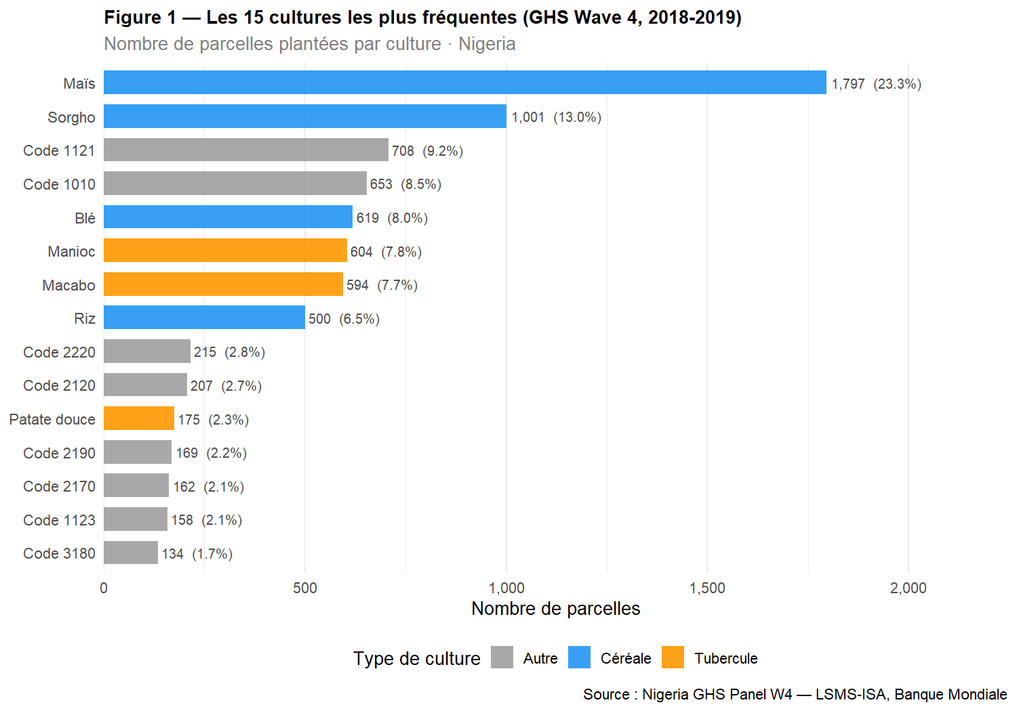
Commentaire. Les céréales dominent le système agricole nigérian en vague 4.

Tâche 26 — Indice de diversification culturale par ménage

Calcul de l’indice
## # A tibble: 2 × 7
## milieu n Moyenne Médiane Écart_type Q1 Q3
## <fct> <int> <dbl> <dbl> <dbl> <dbl> <dbl>
## 1 Urbain 496 2.41 2 1.37 1 3
## 2 Rural 2757 2.77 3 1.48 2 4

Distribution globale (histogramme)
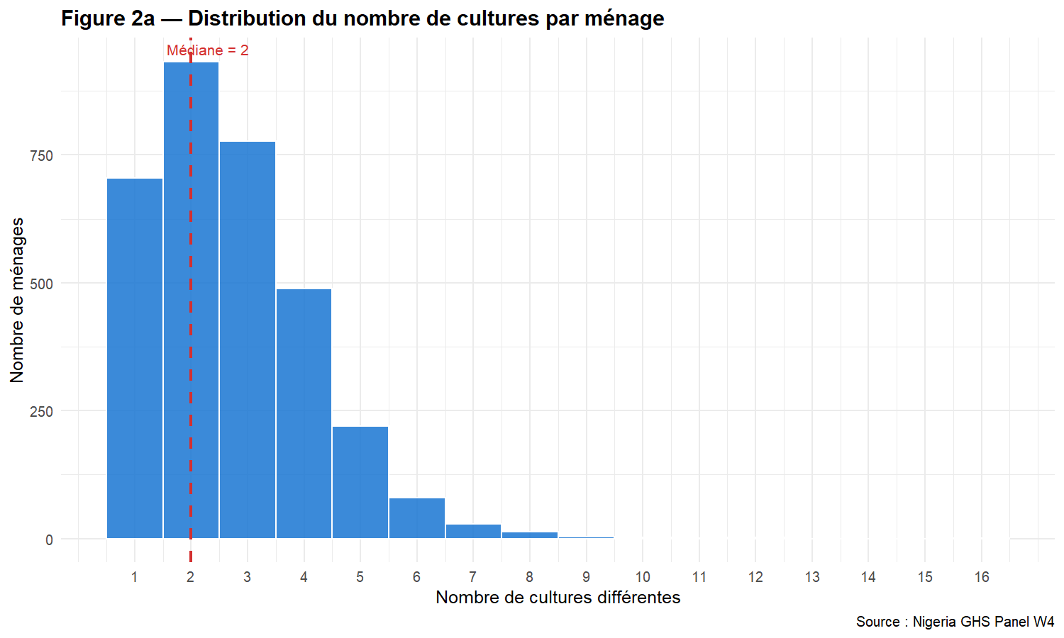

Comparaison Rural / Urbain
## === Test de Wilcoxon ===
##
## Wilcoxon rank sum test with continuity correction
##
## data: nb_crops by milieu
## W = 574653, p-value = 6.062e-09
## alternative hypothesis: true location shift is not equal to 0
## 95 percent confidence interval:
## -4.457566e-05 -5.013725e-05
## sample estimates:
## difference in location
## -3.803334e-05
##
## Taille d'effet (r de rang) : 0.102
## Interprétation : small
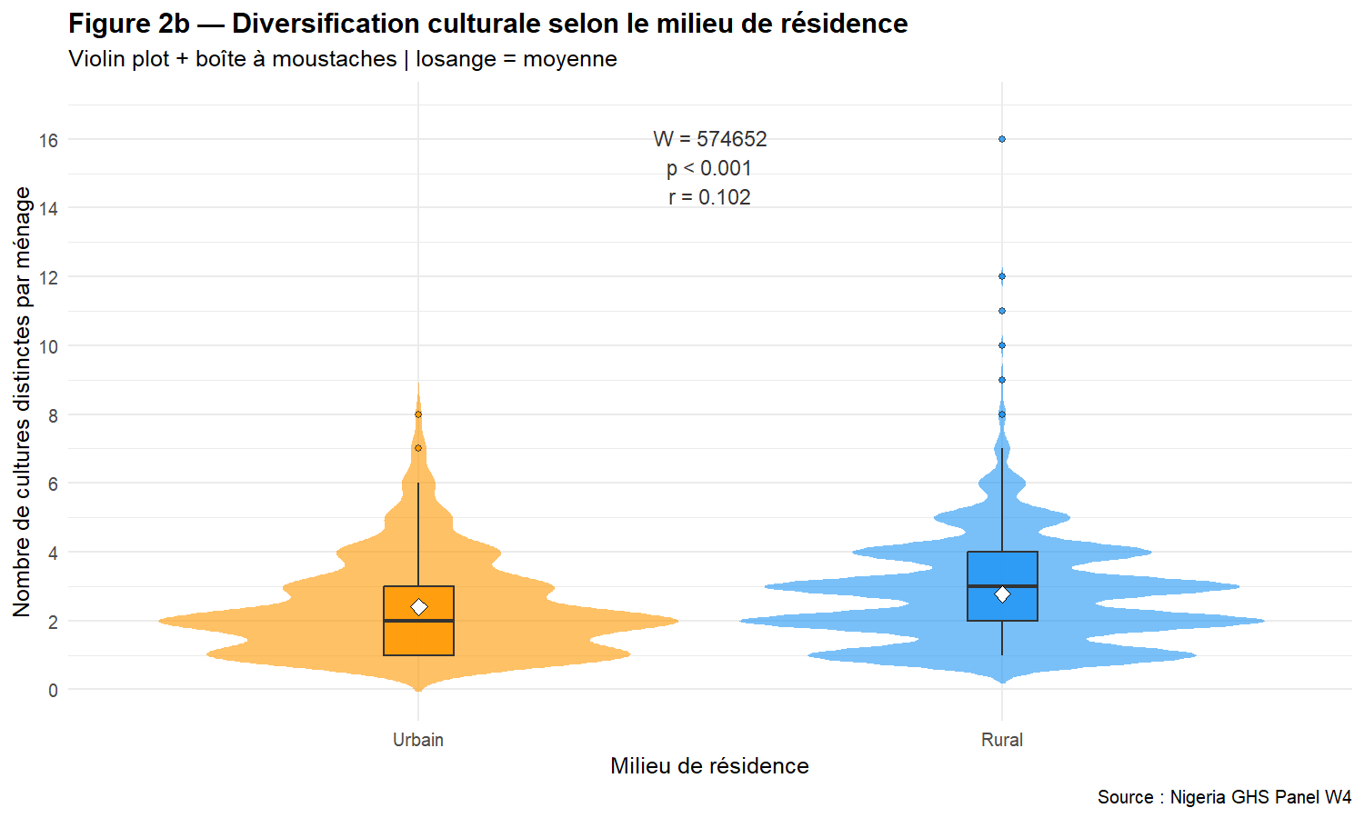
Commentaire. Le test de Wilcoxon-Mann-Whitney permet de comparer les distributions sans hypothèse de normalité. La taille d’effet r de rang quantifie l’amplitude de la différence entre milieux. Les ménages ruraux pratiquent généralement une agriculture plus diversifiée que les ménages urbains, ce qui reflète la logique de subsistance et de résilience face aux aléas climatiques.

Tâche 27 — Utilisation des engrais par type, zone et État

Préparation des données

Test chi-deux : Zone × utilisation d’engrais inorganique
## === Tableau de contingence ===
## Engrais_inorganique
## Milieu 0 1 Sum
## Urbain 378 167 545
## Rural 1641 1270 2911
## Sum 2019 1437 3456
##
## === Test du chi-deux ===
##
## Pearson's Chi-squared test with Yates' continuity correction
##
## data: tab_chi
## X-squared = 31.334, df = 1, p-value = 2.172e-08
##
## V de Cramér = 0.0952

Barplot groupé avec IC 95%
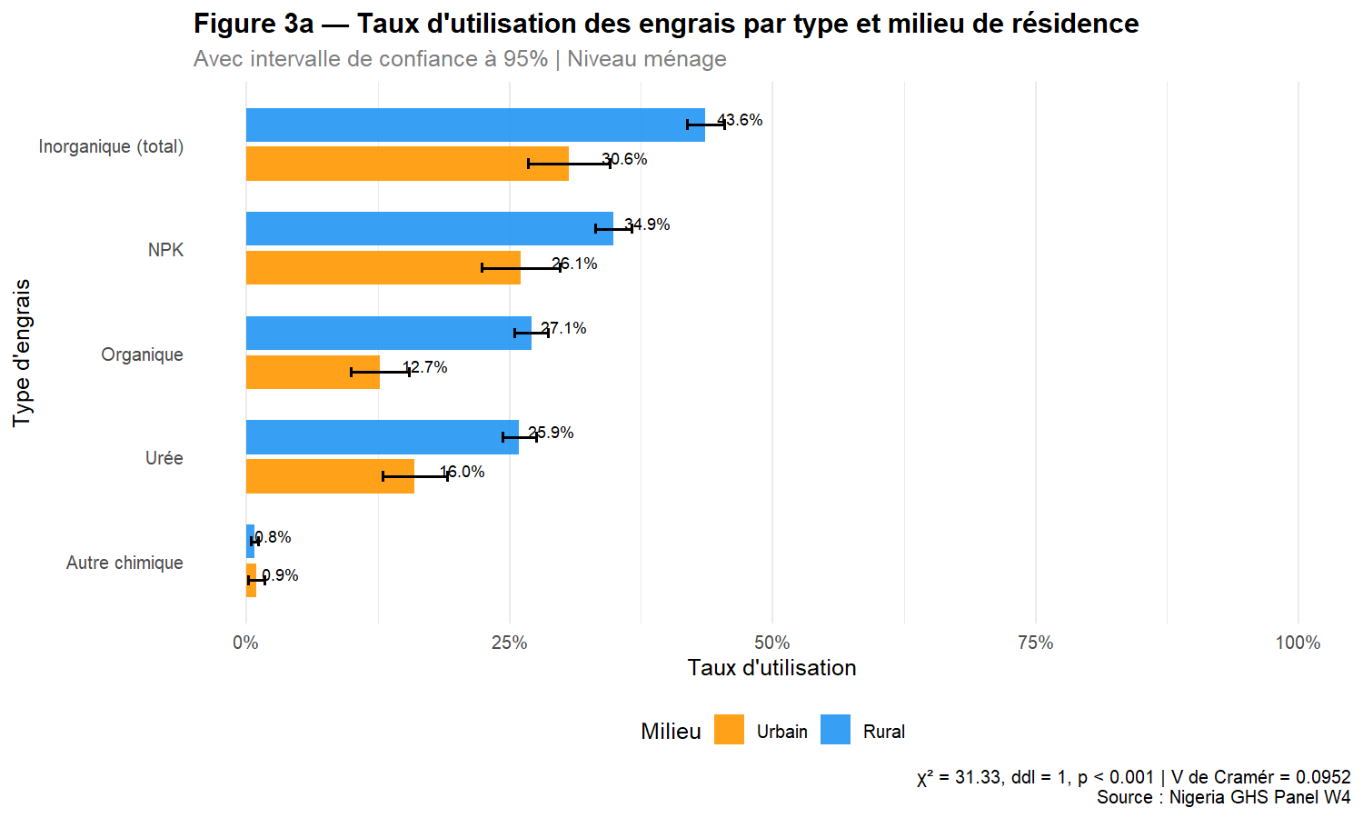

Heatmap : État × Type d’engrais
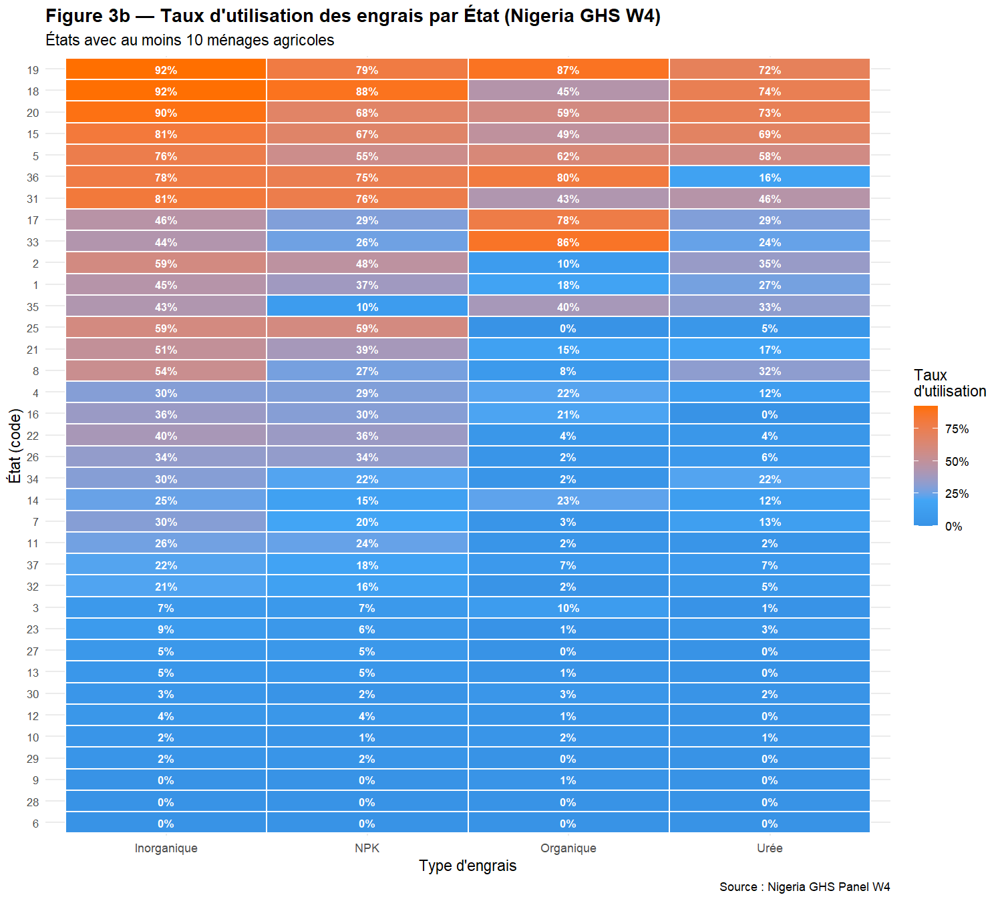
Commentaire. Le test du chi-deux évalue l’indépendance entre le milieu de résidence et l’usage des engrais inorganiques. La disparité est significative si p < 0,05. Le V de Cramér mesure l’intensité de l’association (0 = indépendance, 1 = association parfaite). La heatmap révèle les disparités inter-étatiques dans l’adoption des intrants, qui reflètent à la fois les politiques d’encadrement agricole et les conditions agro-écologiques.

